INTRODUCTION

Sequential pattern mining is one of the very active areas of research. Sequential
pattern mining was first introduced in [1] as: “Given a sequence database, where each
sequence consists of a list of ordered item sets containing a set of different items, and
a user defined minimum support threshold, sequential pattern mining is to find all
sub-sequences whose occurrence frequencies are no less than the threshold from the
set of sequences.”

Progressive sequential pattern mining is a generalized pattern mining methodology
that brings out the most recent frequent sequential patterns. It works on both static as
well as dynamically changing databases and is unaffected by the presence of obsolete
data. It uses the sliding window to progressively update sequences in the database and
accumulate the frequencies of candidate sequential patterns as time progresses. The
sliding window called period of interest (POI) determines the timestamps over which
the algorithm is currently working.

In real world applications, where new data is continuously being added to the pool
of data while the obsolete data is being removed, sequential pattern mining in
progressive databases is one of the major areas of concern owing to its real life
applications such as in the fields of marketing, medical records, sales analysis etc.
The existing algorithms address the issue of effectively finding out frequent sequential patterns fom progressive databases only in a boolean environment. They do not consider the supports associated with data items. They are only concerned with whether or not an item is present in the market basket of a customer, not considering the number of units of a particular item bought by the customer. However, aggregating supports with data items is inevitable in real world. For instance, a customer who visits a retail store may not always buy a single unit of items having day to day use such as egg, bread, butter etc. Also its not necessary that a customer will buy a particuar sequence of products only once in a given time inteval. The patterns are bound to be repeated both by the same customer and by different customers. Repetition of patterns by the same customer is also not accounted for by the existing algorithms.

The contribution of this paper is two algorithms, a basic version and a discretized version, which not only mine frequent patterns from support coupled data but also consider the support associated with patterns themselves.

RELATED WORK

The initial study on progressive sequential pattern mining was proposed by Huang et
al. [2]. The kernel of the algorithm PISA is PS-tree. PS-tree has a root node and
common nodes. Root node is the root of the PS-tree containing nothing but a list of
common nodes as its children. Each common node stores node label, a sequence list
and a timestamp. The label is the same as the element in a sequence. The sequence list
stores a list of sequence IDs to represent the sequences containing this element. The
Period of Interest (POI) is defined as follows:

Definition 1. POI is a sliding window, whose length is a user-specified time interval,
continuously advancing as the time goes by. We are concerned only with the
sequences having elements whose timestamps fall into this period.

When receiving the elements at the arriving timestamp, say t+1, Pisa traverses the
original PS-tree of timestamp t in post order and updates the PS-tree of timestamp t.
While traversing PS-tree, Pisa i) deletes the obsolete elements from, ii) updates
current sequences in, and iii) inserts newly arriving elements into the PS-tree of
timestamp t.

Whenever there are a series of elements appearing in the same sequence, there will be a series of nodes labeled by each element, respectively, with the same sequence IDs in their sequence lists. Then, the first node will be connected to the root node and the second node representing the
following element will be connected to the first node. The other nodes will be connected analogously. Note that, in such a way, the path from root node to any other node will represent the candidate sequential pattern appearing in this sequence. If the same pattern occurs in another sequence ID as well, the sequence ID will be inserted into the sequence list of the same nodes labeled by these elements on the path. On the other hand, if an element appearing in a sequence is
obsolete, the corresponding sequence ID will be removed from the sequence list of the node. In addition, if a node has no sequence in the sequence list, it will be pruned away from PS-tree. Thus, we can ensure that there are only up-to-date candidate sequential patterns in PS-tree.

For root node, all the sequences having new elements are examined. For each candidate element, if the element already appeared at the previous timestamps, it is a child of root node. Then, if the sequence ID has been in the sequence list, the timestamp of that sequence is updated to be the new timestamp. Otherwise, a new sequence is created and inserted into the sequence list of that child. If there is no child node with the same label, a new child node is created with the corresponding
sequence ID in the sequence list. In this way, we have inserted the subsequences containing only one element in PS-tree .

For the common nodes, the obsolete sequences in the sequence list are deleted. If there is no sequence ID left in the sequence list, this node is pruned away and the algorithm proceeds to the next node. However, if there are still some sequences left, Pisa checks them in the sequence list
instead of checking all newly arriving sequences as processing root node. If there is a newly arriving element of the sequence in eleSet, for all combinations of candidate elements in the arriving data, Pisa examines if the element is on the path from root to the current node. If the element is not on the path, it means there is a new candidate sequential pattern. Thus, for this element, Pisa follows the same insertion procedure. If the sequence ID has already been in the sequence list, it means there is the same candidate sequential pattern with a new timestamp appearing in the same sequence. The timestamp of the sequence in the child node should be updated as that of its parent node. Therefore all the candidate sequential patterns have been generated. If the number of sequence IDs in a sequence list is larger than the minimum support times number of sequences in the current POI, the path from root to this node will be output as a
frequent sequential pattern.

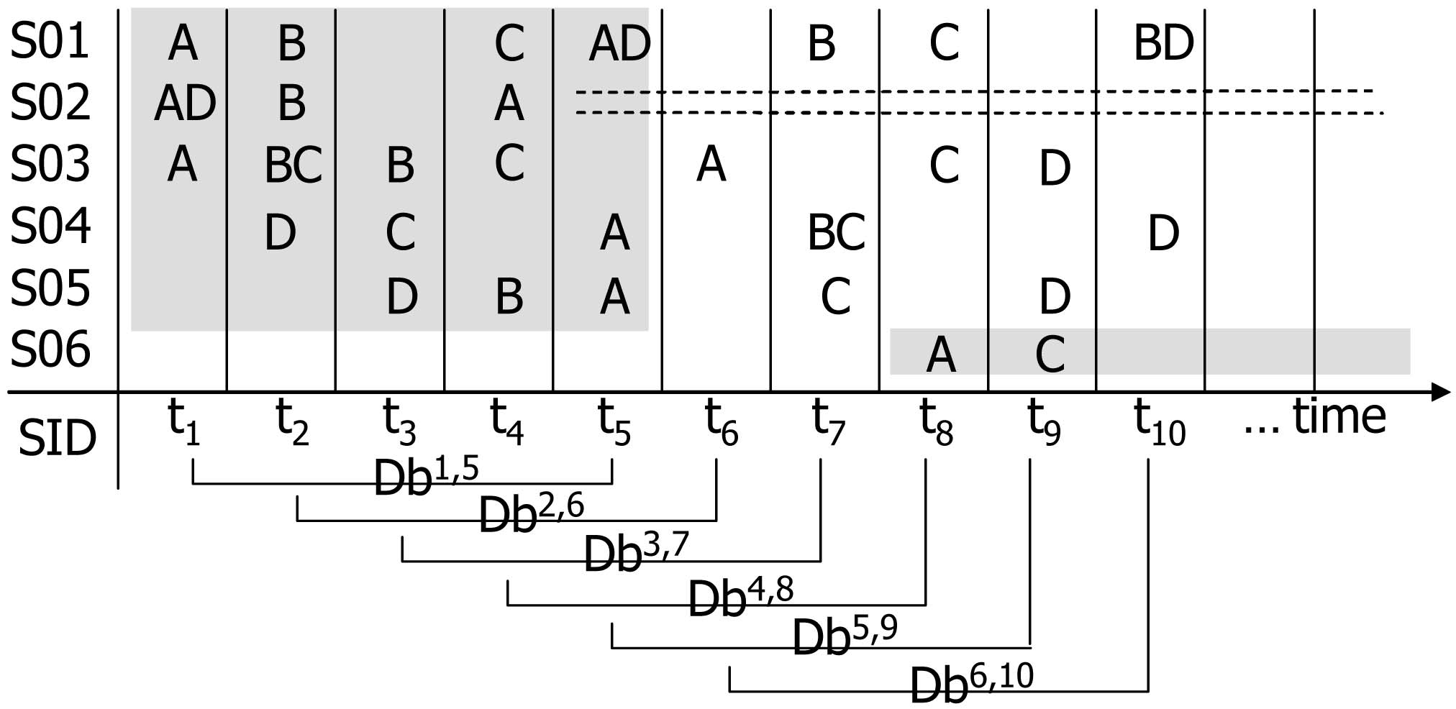

Figure 1

For the database shown in Figure 1, the PS Tree generated at various timestamps will be as shown in Figure 2.

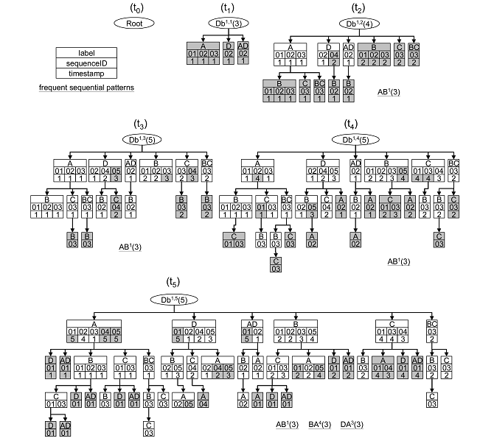

Figure 2

PROBLEM STATEMENT

Consider a sequence ID in market basket data as follows :

S01 | A | B | C |  | AD | B
 | t1 | t2 | t3 | t4 | t5 | t6

If we consider the boolean presence of data as per the existing algorithms, then pattern AB in sequence ID S01 contributes 1 to the total frequency of AB in the entire database. However consider there is a retail store that wants to find the most frequently occuring patterns so that it may make its monthly purchases accordingly. Now the store would definitely be interested in how many times the pattern occurs within the database, regardless of whether the same customer follows the pattern multiple times or different it occurs across different customer purchasing profiles.
Therefore in the above example, if we consider disjoint occurrence, the pattern AB occurs twice(<t1,t2>, <t5, t6>) in sequence ID S01, and if non-disjoint occurences are also considered, then it appears thrice (<t1, t2>, <t5, t6>, <t1, t6>).

Next, consider a sequence ID in the market basket data of following format

S01 | 2A3B | 1A | 1B |  | 1C | 2C
 | t1 | t2 | t3 | t4 | t5 | t6

Here not only do we have the items purchased but also the supports associated with them i.e. the number of units of each item purchased. Lets say in a retail store some of the items are available as super saver packs of multiple units, or the customer may just buy multiple units of an item. Support can be interpreted in any of these ways. Here while finding patterns, 2A1B (<t1, t3>) and 1A1B ( <t2, t3>) are considered as different patterns as opposed to the boolean case where there are no supports and each of these patterns will be equivalent to AB. However, In some applications it might be possible that there are hundreds of different values of supports associated with each data item. If each support associated with a data item is treated separately, the space requirement will be enormous and the PS-Tree will explode. Needless to mention, it won't scale.

Therefore, we propose an algorithm to address the above two issues in a scalable manner.

PROPOSED WORK

This section introduces two algorithms, BASIC SCPISA (Support Coupled Progressive Mining of Sequential Patterns) and DISCRETIZED SCPISA for support coupled data.

BASIC SCPISA

Data Structure used

A k-ary tree is used to store the details of the database. The nodes of the tree are broadly classified as root node and common nodes. Root node is empty and links to the common nodes. The node legend for the common nodes is as shown in Figure 3.

Label
Support
Sequence ID List
Timestamp List
Frequency

Here Label is the item in consideration. Support is the support count associated with that item. Sequence ID is an integer number which represents the sequence numbers in which this item appears. Each sequence ID is marked with the corresponding time stamps. Frequency stores the number of times this item has appeared in the current POI in both dimensions, i.e. it is counted both within a sequence ID and across difference sequence IDs .

Adding new items to the k-ary tree

New items are added to the k-ary tree in a fashion similar to PISA with a few differences. Each support value associated with an item is treated differently, i.e. a separate node is made. When an item appears in the same sequence ID again, instead of updating the timestamp, we simply add another entry for the timestamp under the same sequence ID, and increase the frequency at the node by 1. When a new node is added to the tree, frequency is initialised to 1.

Deleting obsolete items from the k-ary tree

When the POI moves, the timestamp entries having values less than the difference between current timestamp and size of POI, are removed and the frequency is reduced by 1 for each timestamp removed. If all the timestamps under a particular sequence ID get deleted, the entry for that sequence ID is removed. If the frequency count becomes zero, the node itself is removed.

Reporting frequent patterns

Depending on the application requirement, we may report the total number of times a pattern appears, or the total number of disjoint occurences of the pattern. If the frequency value stored in a node is greater than the minimum support times the number of sequences in the current POI, the path from root to this node will be output as a frequent sequential pattern.

If the application needs to consider all the occurences of a pattern irrespective of whether they are disjoint or not, the frequency of a pattern is the maximum of the frequency values stored in the nodes that correspond to that pattern. However, if only disjoint occurences are to be considered, the minimum value is taken.

Limitations of this algorithm

The above proposed algorithm successfully finds out frequent patterns in support coupled data, while solving both the issues highlighted in section ____. However, essentially this algorithm treats each support value associated with a data item as a separate entity. For instance, if we have 1A, 2A, 4A and 5A, there will be different nodes corresponding to each of these. This may result in making the tree very bushy, and hence has a high space complexity. If say there are 100 different support values associated with a single data item, things can go worse.

To address this issue, we present a discretized version of the algorithm which makes buckets of the supports, thus optimizing the space usage.

DISCRETIZED SCPISA

In the discretized version of the algorithm, we do not consider each support associated with a data item separately. Rather, buckets of supports are formed. For instance, if our bucket size if 5, then all 1A, 2A, 3A, 4A, 5A will be put into the same node, 6A to 10A into another, 1B to 5B into another and so on. The support value in the node will be the median of the range of supports associated with that node. For instance for a node that holds 1A to 5A, support value entered in the node will be 3; for 6A to 10A, it will be 7 and so on.

Rest of the algorithm for insertion, deletion and reporting of patterns works in the same way as the basic version.

When the patterns are reported, the support counts associated with the items can be reported according to the user needs which will be a function of the range of the bucket and some other parameters. Default is the median value of the bucket range. Other options can be the maximum value of the range, minimum value of the range, weighted average of the values in the range etc.

The pseudo code for discretized SCPISA is given in figure ____

Algorithm SCPISA (support, POI, Dfactor)
- Var SCPS;
- Var currentTime;
- Var eleSet;
- While(there is still new transaction)
- eleSet = read all ele at currentTime;
- Traverse(currentTime, SCPS, Dfactor)
- currentTime++
End

Procedure Traverse(currentTime, SCPS)
- For(each node of SCPS in post order)
- If(node is Root)
- For(ele of each sequence in eleSet)
- For(all combinations of elements in the ele)
- If(element == label of one of node.child and support - support%Dfactor == support associated with it)
- If(seq is in node.child.seq_list)
- Add currentTime to the list of timestamps
- Increase frequency by 1
- Else
- Create a new sequence with currentTime
- Else //create a new child
- Create a new child with element, support, seq, currentTime and frequency=1
- Else//node is common node
- For(every seq in the seq_list)
- For(every timestamp under the given seq)
- If(seq.timestamp <= currentTime-POI)
- Delete timestamp from timestamp list and decrement frequency by 1
- If(number of timestamps under the given seq = 0)
- Delete seq from the seq_list
- If(there is new ele of the seq in eleSet)
- For(all combinations of elements in the ele)
- If(element is not on the path from root with support = support – support%Dfactor)
- If(element == label of one of node.child && support == support – support%Dfactor)
- If(seq is in node.child.seq_list)
- Add a new timestamp = max(seq.timestamp) to the timestamp list
- Increment frequency by 1
- Else
- Create a new sequence with max(seq.timestamp)
- Increment frequency by 1
- Else //create a new child
- Create a new child with element, support, seq, seq.timestamp & frequency(=1)
- If(seq_list.size == 0)
- Delete this node and all of its children from its parent
- If(frequency >= support * number_of_sequences)
- Output the labels of path from root to this node as a frequent SP

WORKING OF THE ALGORITHM
Let us consider a sample database shown in Table ___ and build a tree corresponding to it.

S01 | 1A | 1B | 1A | 1B | 1B
S02 | 2C1D | 1A2B | 3C | 1B | 5D
S03 | 9D |  | 6D6C | 3B | 2A
S04 | 5A | 4B | 8B
 | T01 | T02 | T03 | T04 | T05

If we consider only boolean presence of data, the K-ary tree constructed at different time instances will be

COMPLEXITY ANALYSIS AND COMPARISON WITH THE BOOLEAN VERSION
The time complexity is mainly
dominated by traversing the data structure of each
algorithm. Therefore, we focus on deriving the space
complexity of each data structure first. Then, we examine

the time complexity of procedure traverse in both Basic SCPISA and Discretized SCPISA.
Let |D| be the average number of sequences in the database, P be the
probability of a sequence having items at each timestamp,
|T| be the average number of items appearing in the same
sequence at the same timestamp, L be the length of
POI, |S| be the average number of different support values associated with each data item and B be the discretization factor i.e. size of the bucket in discretized SCPISA.
we assume that items are
independent of one another. In addition, whether items
appear in a timestamp is independent of whether items
appear in another timestamp.
The total time complexity of algorithm PISA is __________________________________ , i.e. it is proportional to _____________. As discussed earlier the time complexity of the algorithm is mainly dominated by traversing the data structure of the algorithm.

In case of Basic SCPISA, since there is a separate node for each support value associated with each data item, therefore the number of nodes is |S| times the number of nodes in boolean PISA. Hence time complexity of Basic SCPISA will be |S| times the complexity of PISA i.e. proportional to __________________-.

In Discretized SCPISA, since the entries corresponding to B different values of support are clubbed together into one node, under the same label; therefore the time complexity will be 1/B times that of Basic SCPISA, i.e. it will be proportional to ___________________.

RESULTS and ANALYSIS

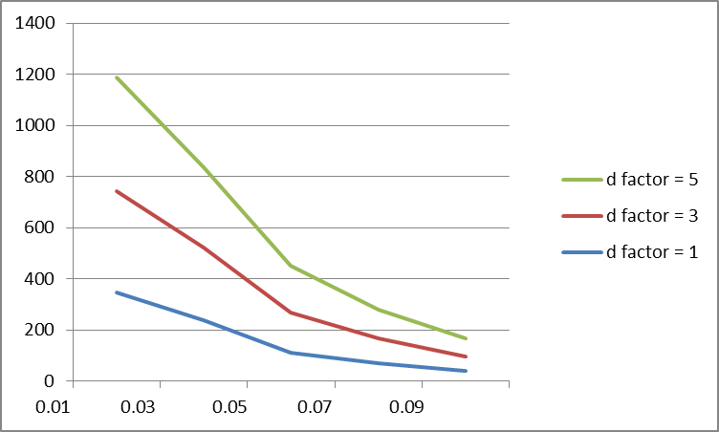

We carried out our experiments with support coupled transaction dataset consisting of _______ transaction IDs. The horizontal axis shows different support values and the number of frequent patterns are plotted on the vertical axis. The three curves correspond to three different values of discretization factor. As can be seen from the graph, as the minimum support is increased, the number of frequent patterns decreases. However, as d-factor is increased at the same value of minimum support, the number of frequent patterns increases. This is because due to larger d-factor, more number of items are stored at the same node, under the same label.

